Comprehensive Lab 3

Arielle Dow
Department of Computer Science: The University of Texas at El Paso
CS 1101: Introduction to Computer Science Lab
Instructor: Montserrat Molina
Teaching Assistant: Asif Rahman
December 5, 2025

Lab Report
Game Summary
If you loved classic Pokémon battles, or if you’re a fan of Star Wars, Marvel, or DC. you’re going to love this expanded Battle Simulator! This Java text-based interactive game lets players choose their favorite universe and jump into strategic, character-driven combat. Each universe features a variety of characters with unique stats, giving you endless possibilities!
Players can battle a computer opponent, challenge a friend in two-player mode, or switch universes at any time to try out new characters and strategies. Want to sit back and watch the action instead? You can view a fully recursive AI-vs-AI simulated battle between the easy and medium-mode computers to see how the strategies work out.
There is even a new game mode called Multiverse Mayhem. This new game mode allows you to teleport into a new random universe in the middle of a battle (instead of forfeiting) to find a new opponent. Your character even heals during the teleportation!
This is an easy game to play and is perfect for Pokémon, Star Wars, Marvel, or DC lovers or anyone who enjoys strategy and competition. Are you ready to find out who the ultimate champion is?
What I learned
The main thing I learned writing this code is a deeper understanding of classes and objects, and their usefulness. Honestly, before this comprehensive lab I didn’t really understand why we would use different classes when we could just create methods within the same class. When I was refactoring my code, I started to understand why we would want different classes for certain use cases. In this instance, having Character and Game as different classes made it a lot easier to keep track of what is happening. As a personal preference, I also enjoy having main shorter, and having the bulk of the code in other classes.
Biggest Challenges
I found this lab pretty simple, it was the shortest and took the least amount of time and effort to complete compared to the other labs. The biggest challenge though was compiling and running my code after the project was completed. I was compiling my classes as I went to check for bugs, but when I thought everything was completed, I went to run main for the first time and nothing happened. I attempted to troubleshoot all the ways I knew how, but it still wasn’t working. When I went to office hours for help the only problem was that I was running an empty copy of the code and not the actual file I was working on. Now I know how to double check the directory and where I am working to ensure I am running the correct file.
Testing Report
Welcome and changing universe
When the battle simulator is run the first thing outputted to the user is a welcome message and then prompts them to choose a universe to play in. If the user inputs anything invalid and invalid input message will be outputted and will prompt them to try again. Once the user inputs a valid choice, the user will be brought to the main menu. This error handling is identical to option 5 when the user wishes to change universe.
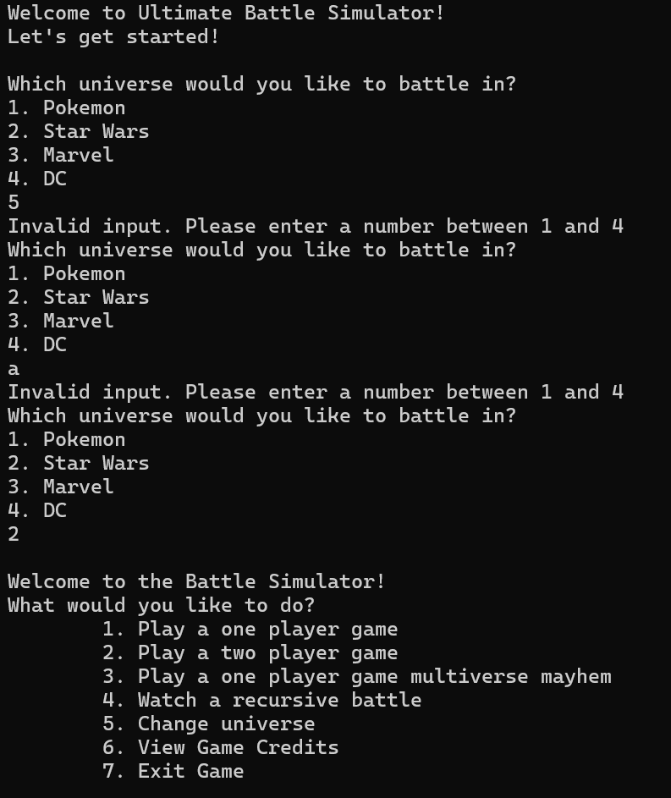
Main Menu
In the main menu, the user has seven options to choose from, numbered one through seven. If they input something that is not a number from one to seven, an invalid input statement is printed to the console to let them know and prompt them to try again. If they type in a valid option it will either start a game (either one player or two player), play multiverse mayhem, watch a recursive battle, change universes, print the game credits, or exit the game, depending on their choice.
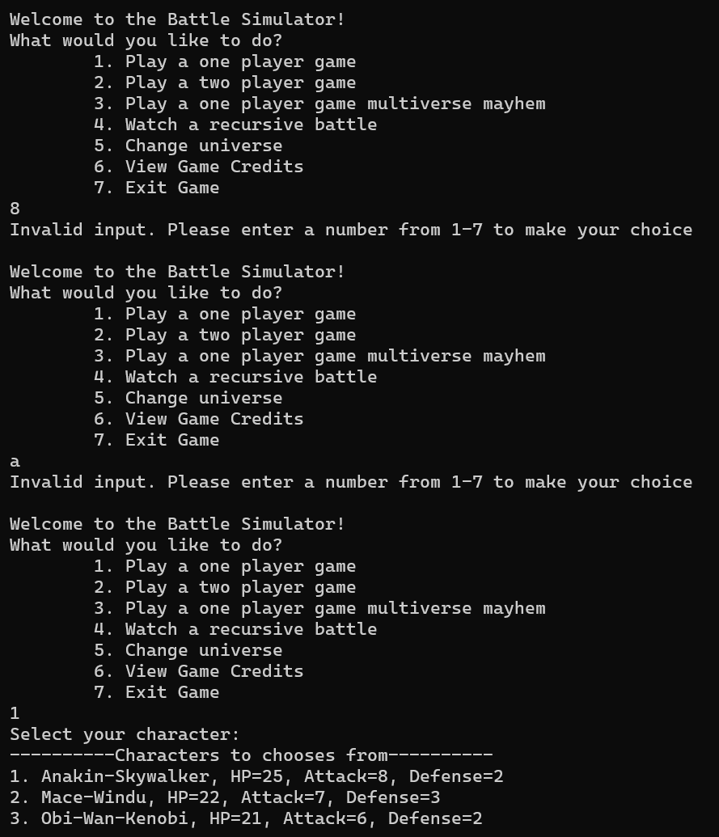
One Player Game
When the user chooses the option to play a one player game, first they are prompted to choose a character to play as. If they input a number outside the range of characters to choose from, or if they input a letter or symbol, they will be prompted to try again. After selecting their character, the user is then prompted to choose their difficulty level, if the user inputs something invalid they will be prompted to try again. After choosing their difficulty level the battle will begin.
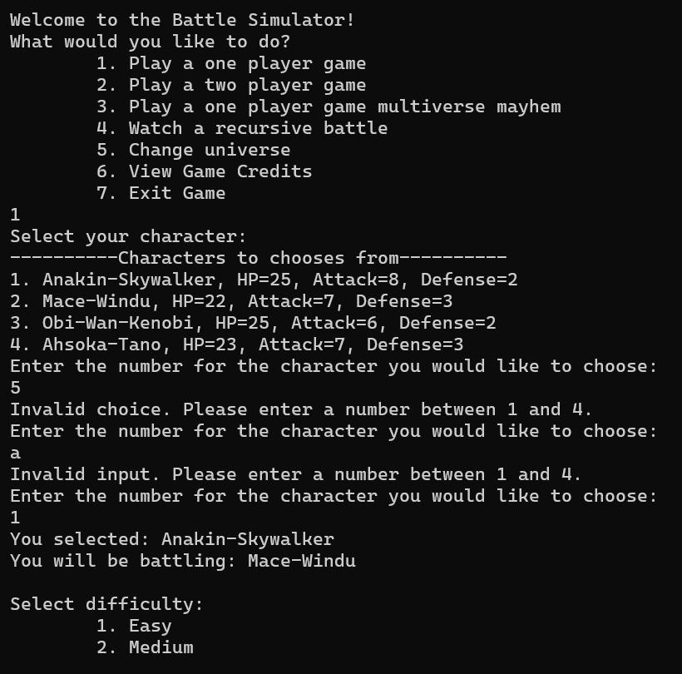
Two Player Game
If the user chooses option two, a two player game will begin. The user will be prompted to input the names of each of the players. If player two tries to choose the same character that player one has already chosen a message indicating that character has already been chosen will be outputted and will prompt the user to choose a different one. Once both players have selected their character the battle will begin.
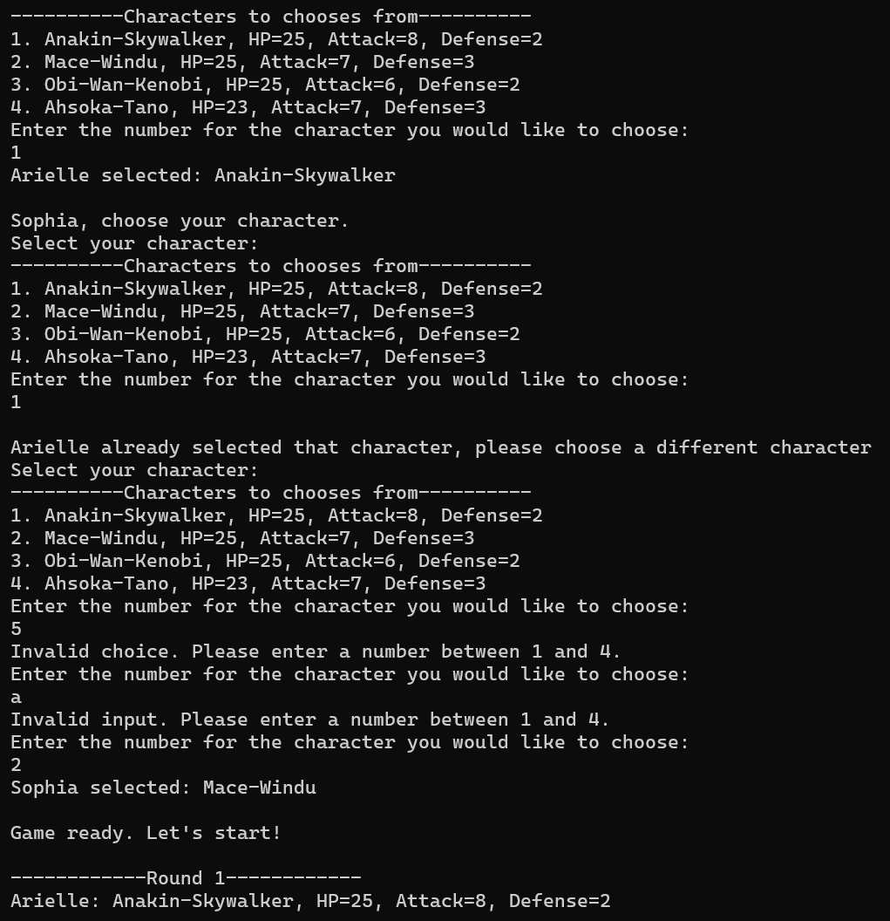
Multiverse Mayhem
When the user chooses option 3 in the main menu, the user will play a one player game against a computer. This is almost identical to the normal one player game, however in this mode in addition to the options to attack, heal, and forfeit, players also have the option to teleport. When a player chooses this option, they teleport into a randomly selected universe, and a new opponent from the new universe is selected. The player also heals 50% of their max health, so some strategy is required when choosing this option.
